Coach Module

Sign In:

Enter the registered user name and password to sign in.

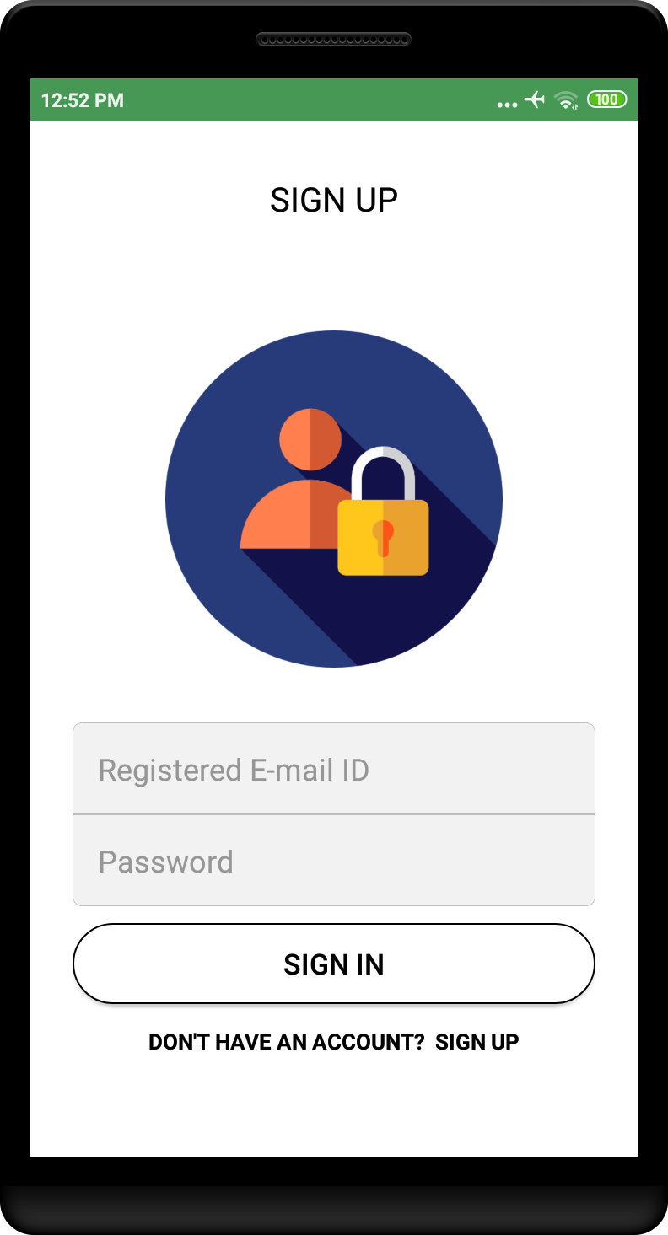

Sign Up:
Enter Details for Registration .

Ask Permission to access users device.
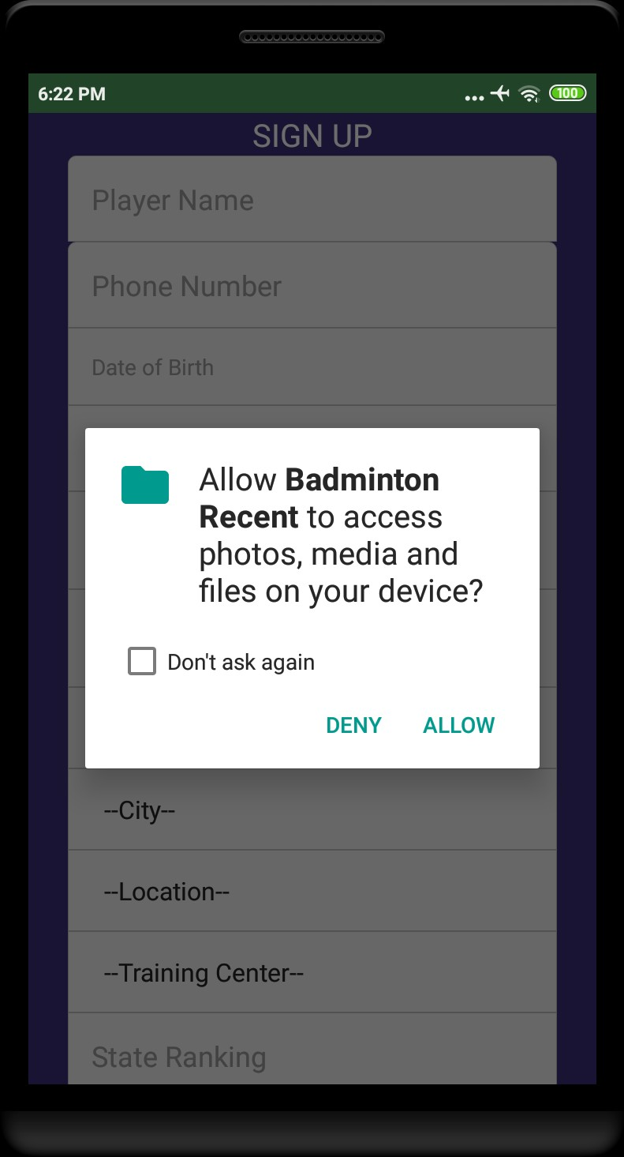

Enter basic informations such as name,date of birth etc., as shown below.

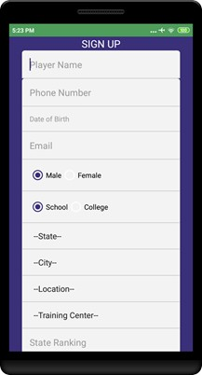
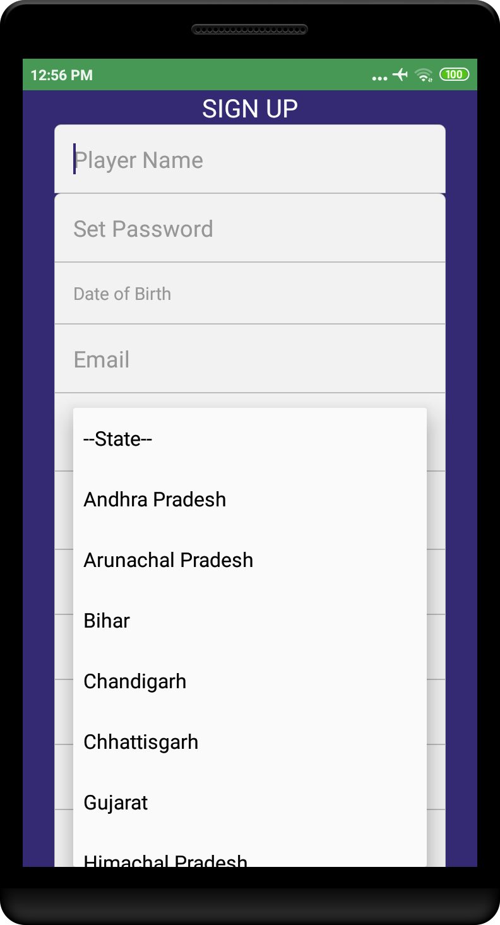

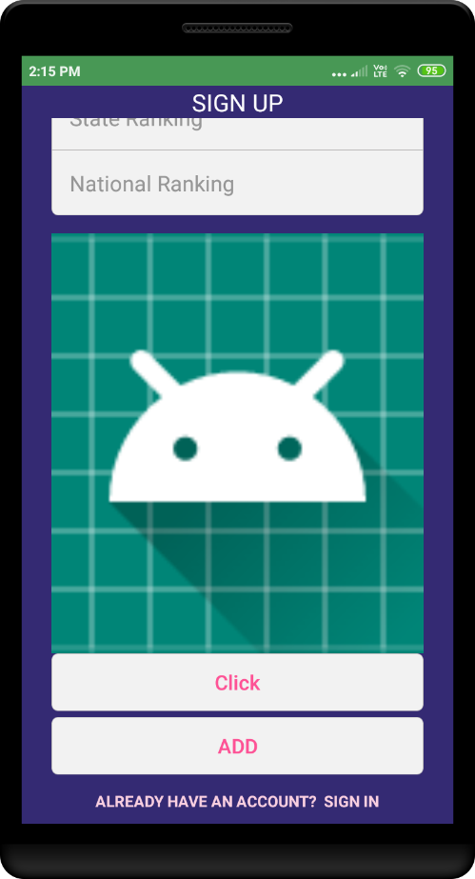

After Sign In

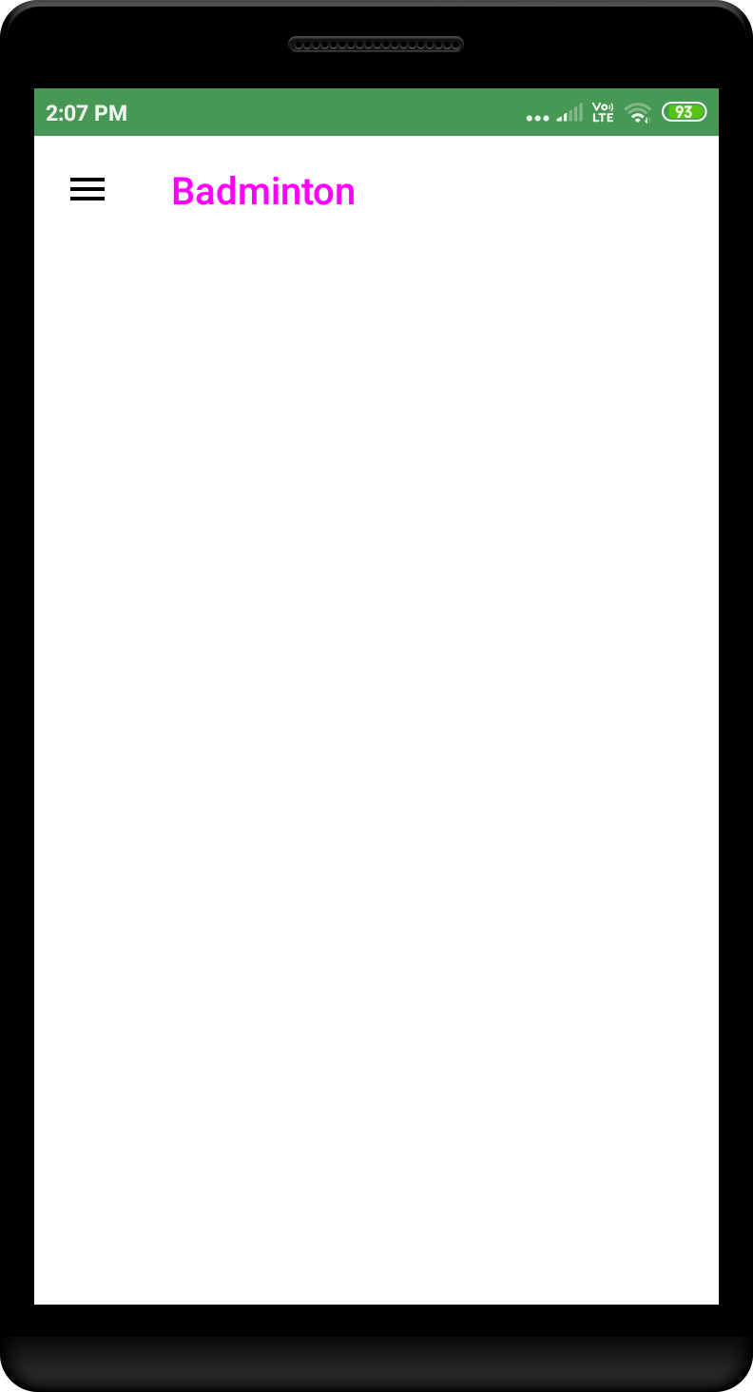

Options in the navigation.

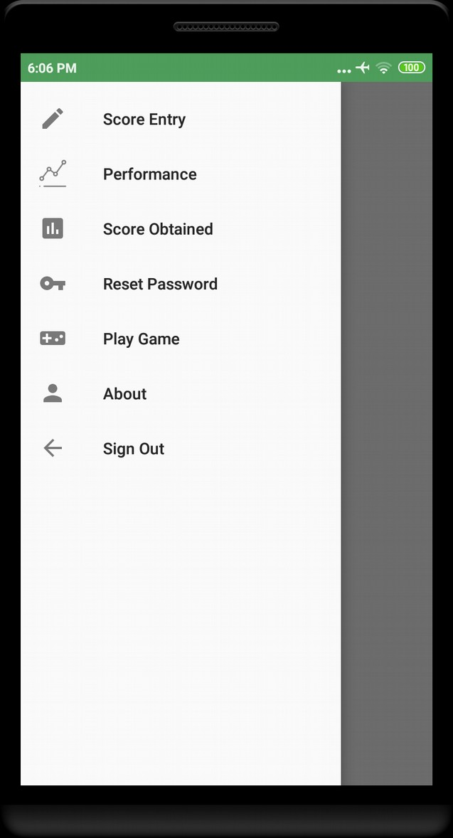
On Clicking score entry

So here coach will be entering city,academy which he belongs and he will select the level where only that level players will apper to provide score be coach.
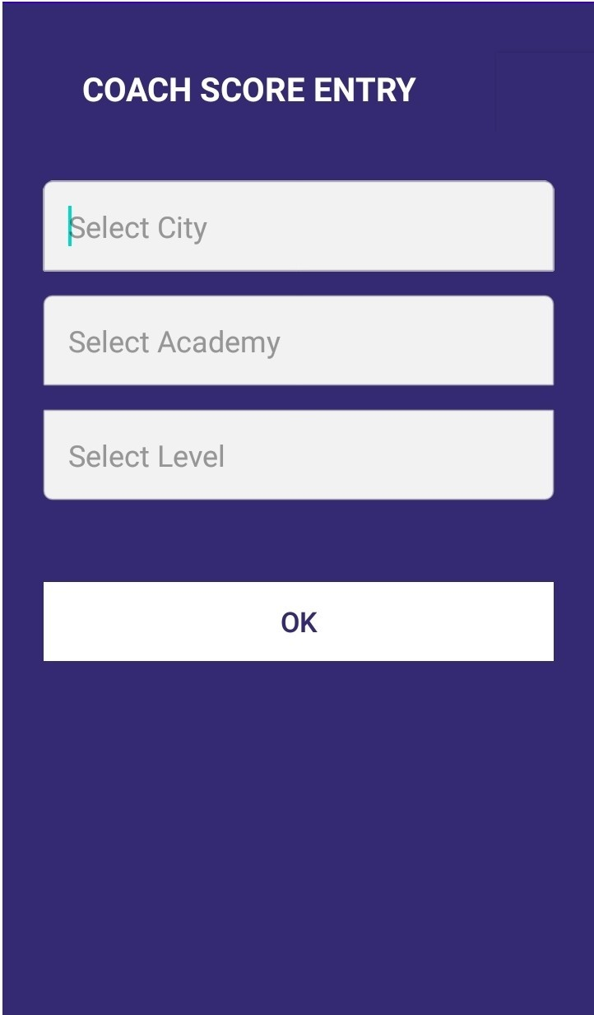

Navigation to Search Player

After clicking ok this will navigate to search player ,where list of players who belongs to the academy selected previously will be displayed respective to the levels.Coach can also be able to search player.

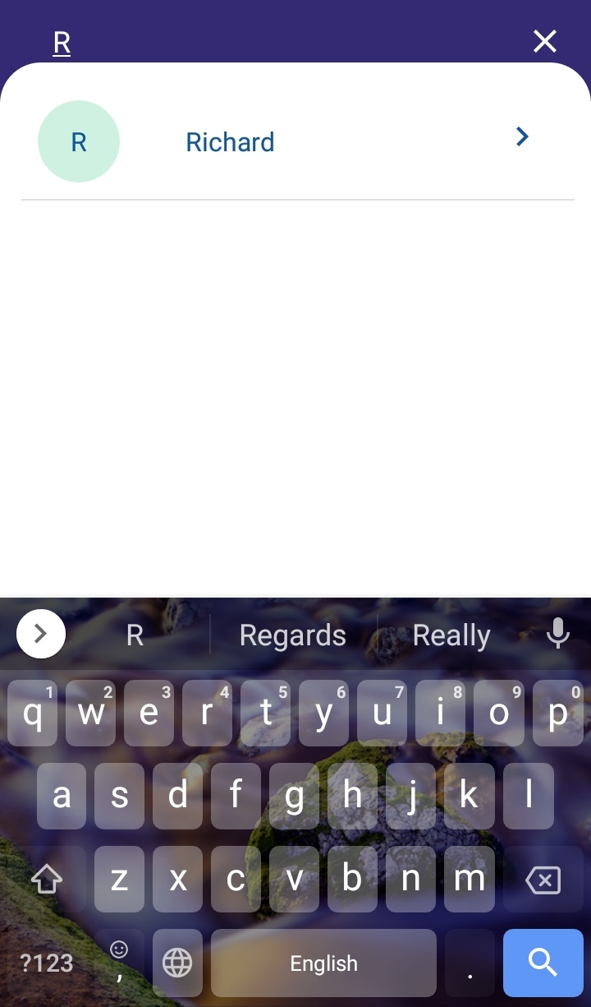
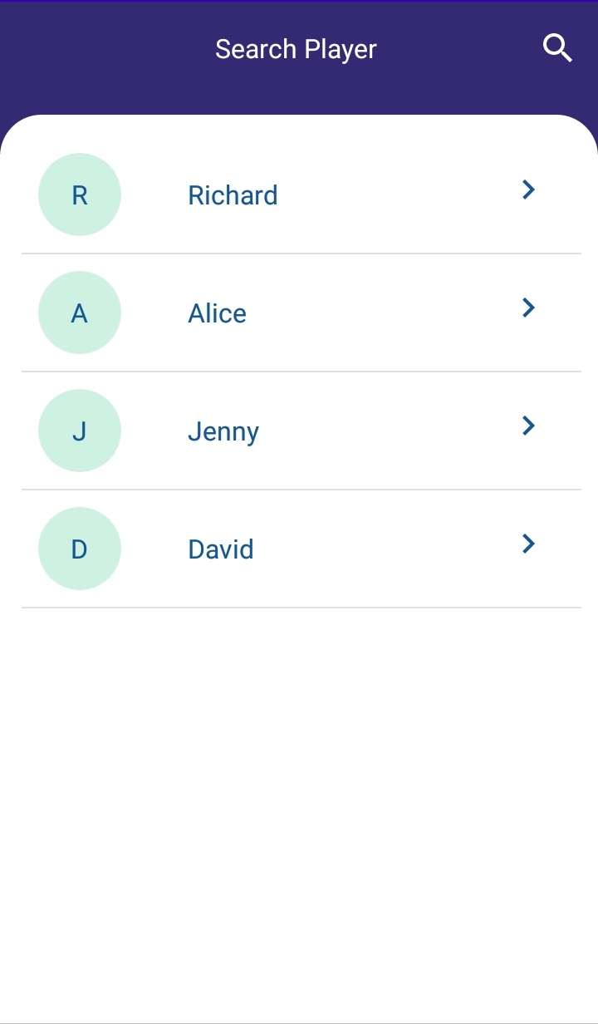

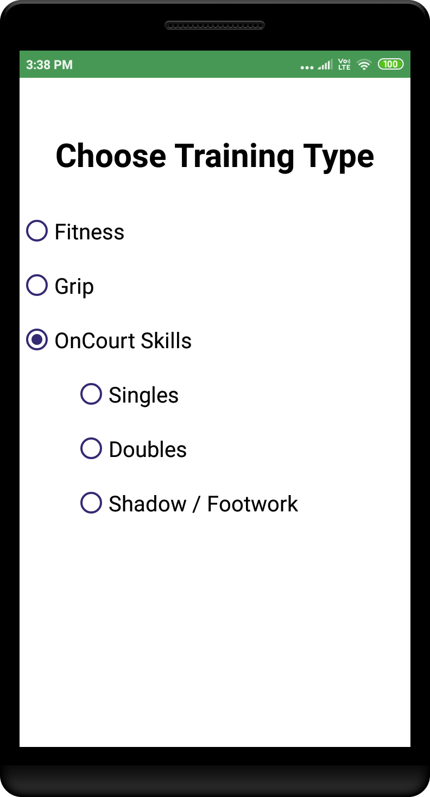
After selecting player this navigate to Selection of Training Category

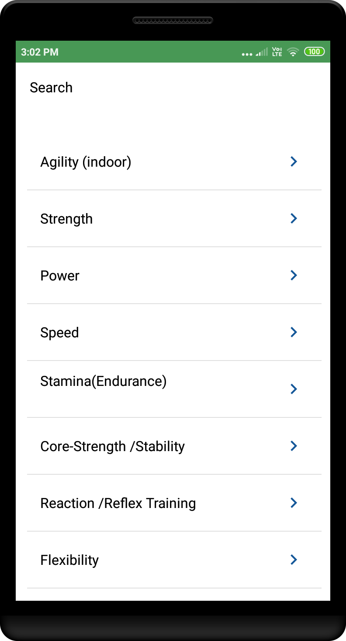
On clicking fitness:

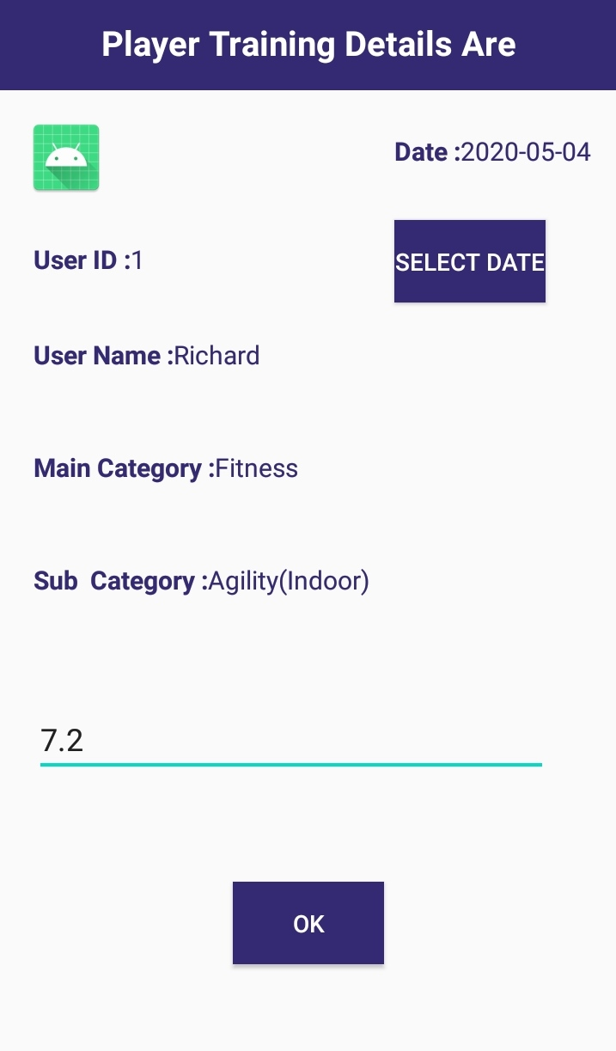

Here all details of player will be displayed and there is option to select date ,by default the date will last score entered by coach,if the coach wanted to give score on particular date then he/she can select date.

Once click ok ,get Successful Score Entry and will be navigated to Home Screen.

Click on Performance

when clicked on performance the line graph will be displayed respecitive to date and score obtained.This graph represents score given by coach.

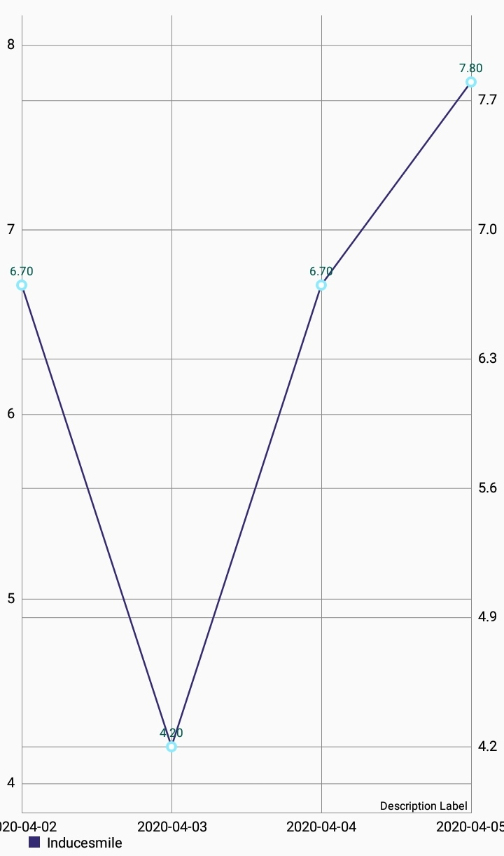
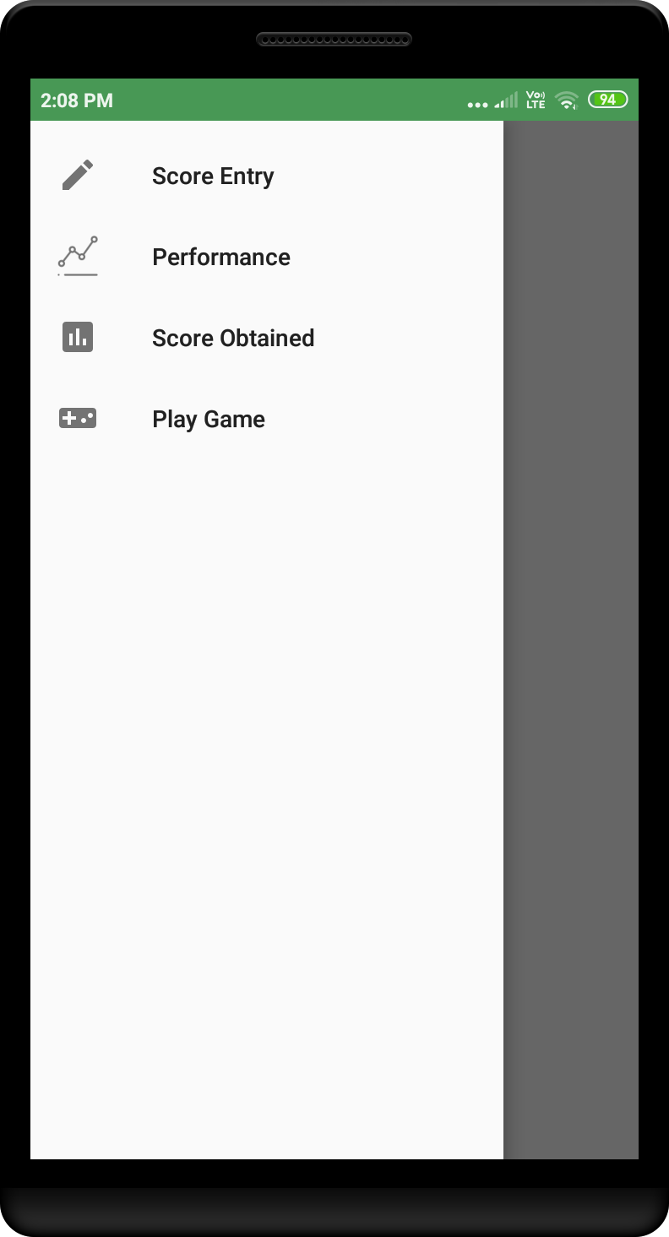

Clicked on Score Obtained

when clicked on Score obtained then below graph will be displayed respecitive to date and score obtained.This graph represents score obtained by player.

